5.72: The key idea in solving this problem is to recognize that if the system is accelerating, the tension that block A exerts on the rope is different from the tension that block B exerts on the rope. (Otherwise the net force on the rope would be zero, and the rope couldn’t accelerate.) Also, treat the rope as if it is just another object. Taking the “clockwise” direction to be positive, the Second Law equations for the three different parts of the system are:
Block A (The only horizontal forces on A are tension to the right, and friction to the left):
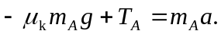
Block B (The only vertical forces on B are gravity down, and tension up):
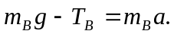
Rope (The forces on the rope along the direction of its motion are the tensions at either end and the weight of the portion of the rope that hangs vertically):
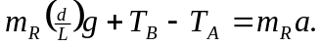
To solve for a and eliminate the tensions, add the left hand sides and right hand sides of the three equations:
(a) When 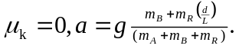 As the system moves, d will increase, approaching L as a limit, and thus the acceleration will approach a maximum value of 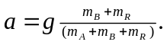
(b) For the blocks to just begin moving, 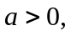 so solve 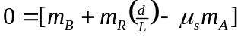 for d. Note that we must use static friction to find d for when the block will begin to move. Solving for d, 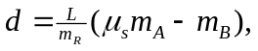 or 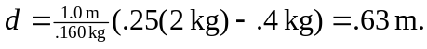.
(c) When This is not a physically possible situation since 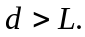 The blocks won’t move, no matter what portion of the rope hangs over the edge.

